Space News Update – October 2015
By Pat Williams
IN THIS EDITION:
- Kerberos completes the family portrait of Pluto’s moons.
- Voyager 1 helps solve interstellar medium mystery.
- A rare re-entry of a suspected rocket body from a very high orbit.
- Europa has the potential to harbour life.
- Astronaut brains as beacons for researchers.
- The first commercial 3D printer to be launched into space.
- Links to other space and astronomy news published in October 2015.
Disclaimer - I claim no authorship for the printed material; except where noted.

MYSTERIOUS KERBEROS – REVEALED BY NEW HORIZONS
Images of Pluto’s tiny moon Kerberos taken by NASA’s New Horizons spacecraft –and just sent back to Earth this week – complete the family portrait of Pluto’s moons.

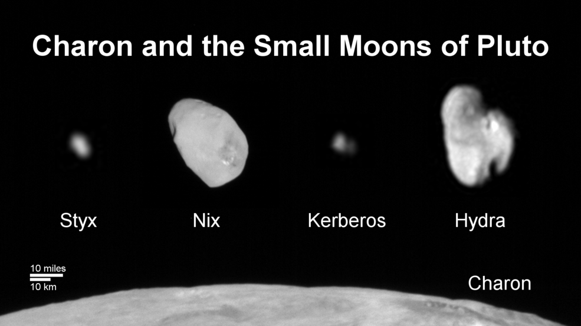

Family Portrait of Pluto’s Moons: This composite image shows a sliver of Pluto’s large moon, Charon, and all four of Pluto’s small moons, as resolved by the Long Range Reconnaissance Imager (LORRI) on the New Horizons spacecraft. All the moons are displayed with a common intensity stretch and spatial scale (see scale bar).
Charon is by far the largest of Pluto’s moons, with a diameter of 751 miles (1,212 kilometers).
Nix and Hydra have comparable sizes, approximately 25 miles (40 kilometers) across in their longest dimension. Kerberos and Styx are much smaller and have comparable sizes, roughly 6-7 miles (10-12 kilometers) across in their longest dimension.
All four small moons have highly elongated shapes, a characteristic thought to be typical of small bodies in the Kuiper Belt. Credits: NASA/JHUAPL/SwRI

The new data, downlinked from the New Horizons spacecraft on Oct. 20, show that Kerberos appears to have a double-lobed shape, with the larger lobe approximately 5 miles (8 kilometers) across and the smaller lobe approximately 3 miles (5 kilometers) across. Science team members speculate from its unusual shape that Kerberos could have been formed by the merger of two smaller objects. The reflectivity of Kerberos’ surface is similar to that of Pluto’s other small moons (approximately 50 percent) and strongly suggests Kerberos, like the others, is coated with relatively clean water ice.
Mysterious Kerberos – revealed by New Horizons (22 October 2015)

VOYAGER 1 HELPS SOLVE INTERSTELLAR MEDIUM MYSTERY

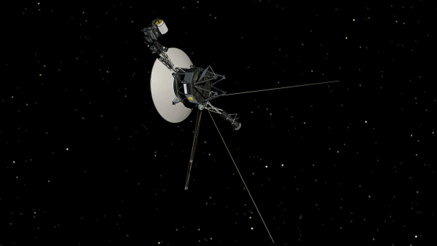
This artist's concept shows NASA's Voyager spacecraft against a backdrop of stars.
(courtesy: NASA/JPL-Caltech)

NASA's Voyager 1 spacecraft made history in 2012 by entering interstellar space, leaving the planets and the solar wind behind. But observations from the pioneering probe were puzzling with regard to the magnetic field around it, as they differed from what scientists derived from observations by other spacecraft. They reanalysed the magnetic field data and found that the direction of the magnetic field has been slowly turning ever since the spacecraft crossed into interstellar space. They believe this is an effect of the nearby boundary of the solar wind, a stream of charged particles that comes from the sun. Researchers predict that in 10 years Voyager 1 will reach a more "pristine" region of the interstellar medium where the solar wind does not significantly influence the magnetic field.
While Voyager 1 will continue delivering insights about interstellar space, its twin probe Voyager 2 is also expected to cross into the interstellar medium within the next few years. Voyager 2 will make additional observations of the magnetic field in interstellar space and help scientists refine their estimates.
Voyager 1 helps solve interstellar medium mystery (29 October 2015)

A RARE RE-ENTRY OF A SUSPECTED ROCKET BODY FROM A VERY HIGH ORBIT

Returning to Earth Courtesy; ESA

A rare re-entry of a suspected rocket body from a very high orbit next month offers an excellent opportunity to gather data to improve our knowledge of how objects interact with Earth’s atmosphere. The object, dubbed WT1190F, is orbiting Earth every three weeks in a highly ‘eccentric’ – that is, non-circular – orbit. The expected re-entry of what is likely to be a rocket body poses very little risk to anyone but could help scientists improve our understanding of how any object – man-made or natural – interacts with Earth’s atmosphere. It is now predicted to re-enter Earth's atmosphere in a few weeks, around 06:19 GMT (11:49 local; 07:19 CET) on 13 November 2015. A significant fraction if not all of it can be expected to completely burn up in the atmosphere. Whatever is left is expected to fall into the ocean about 100 km off the southern coast of Sri Lanka. Its mass is not sufficient to cause any risk to the area, but the show will still be spectacular, since for a few seconds the object will become quite bright in the sky.
Re-entry data will help improve prediction models (23 October 2015)

EUROPA HAS THE POTENTIAL TO HARBOUR LIFE

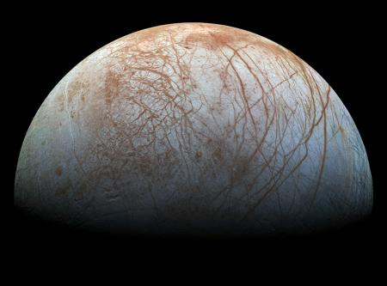
The puzzling, fascinating surface of Jupiter's icy moon Europa looms large in images taken by NASA's Galileo spacecraft. Credit: NASA/JPL-Caltech/SETI Institute

Jupiter's moon Europa is believed to possess a large salty ocean beneath its icy exterior, and that ocean, scientists say, has the potential to harbour life. We have known for a long time that Europa's fresh icy surface, which is covered with cracks and ridges and transform faults, is the external signature of a vast internal salty ocean. The areas of chaos terrain show signatures of vast ice plates that have broken apart, shifted position, and been refrozen. These regions are of particular interest, because water from the oceans below may have risen to the surface through the cracks and left deposits there. Directly sampling Europa's ocean represents a major technological challenge and is likely far in the future. If we can sample deposits left behind in the chaos areas, it could reveal much about the composition and dynamics of the ocean below. That ocean is thought to be as deep as 100 kilometers.
Probing the mysteries of Europa, Jupiter's cracked and crinkled moon (27 October 2015)

ASTRONAUT BRAINS AS BEACONS FOR RESEARCHERS

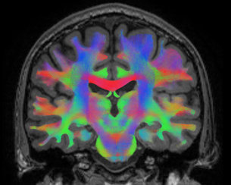
Neural networks shown in MRI scan Illuminating neural networks
Copyright Ben Jeurissen - iMinds-Vision Lab / Department of Physics, University of Antwerp

How astronauts adapt to the stresses of living in space is helping researchers to pinpoint the causes of common disorders on Earth. From the brain’s point of view, living in space is very stressful. The signals from an astronaut’s body in space go haywire as they float in weightlessness. The inner ear reports that it is falling, but the eyes show that nothing is moving. Spacewalks can be extra stressful. As fluid shifts to the head, the brain usually interprets this extra pressure as a sign it is upside down – but in space there is no up or down. The body clock might signal that it is tired after a day’s work on the International Space Station, but astronauts experience 16 sunrises and sunsets every 24 hours. Despite all these conflicting signals the brain adapts and within a few days astronauts float through their home in space as if born there.
The amazing ability of our brains to adapt to new experiences is what makes us survive and thrive, but brains also seem to benefit from the past. Experienced astronauts need less time to readapt to weightlessness than rookies, even if the missions are years apart.
Researchers at the University of Antwerpen, Liege and Leuven in Belgium have devised the ‘Brain-DTI’ study to learn more about how astronauts’ brains adapt to spaceflight. Before and after their flights, up to 16 astronauts will be put in an advanced MRI scanner. The images show the brain’s neural networks and how the connections change after the astronauts’ experiences in space. The research has far to go but it is already revealing some areas of the brain that are involved in adapting to new experiences based on conflicting signals from the body – and pointing to areas of interest for people on Earth.
Upside down or right way up? Several common disorders found on the ground arise from the brain not adapting to signals from the body correctly. A type of vertigo, for example, can develop when the brain does not adapt to conflicting signals from the inner ear, much like when an astronaut is in space. Medical researchers now have a starting point to look for problem areas in the complex brain structure in people who suffer from such disorders. “Ideally, we would have brain scans of people when they were healthy and after they started suffering from a disorder, because then we can see where the changes have taken place. But such an ideal situation does not exist, and neither can we give subjects a traumatic experience on purpose, of course.” For the first time a controlled study using advanced MRI methods is showing researchers where to look in the brain’s complex neural network to target areas for further study and cures. The Brain-DTI study should finish collecting data in 2018 but the first paper has already been published. Astronaut brains as beacons for researchers (8 October 2015)

THE FIRST COMMERCIAL 3D PRINTER TO BE LAUNCHED INTO SPACE
Lowe's Innovation Labs has partnered with aerospace company Made in Space, to become the first to launch a commercial 3D printer to space. The Lowe’s 3D printer is slated to arrive at the ISS in early 2016. From 200 miles above Earth, astronauts can use 3D printing technology to create a tool on-demand and produce parts they may not have onboard and immediately available. "Lowe’s and Made in Space share a vision of how 3D printing can revolutionize retail and home improvement, while also changing the way astronauts work in space," said Kyle Nel, executive director of Lowe’s Innovation Labs. "This is just the beginning of a broader partnership with Made in Space that will bring tools to space and new technology to Earth. For the first time, astronauts can now manufacture what they need, when they need it in space," said Jason Dunn, chief technology officer and co-founder of Made in Space. "We have successfully demonstrated the technology’s capabilities in space. And now with the launch of the permanent additive manufacturing facility to the ISS, we are enabling humanity to manufacture things off the planet."
Lowe's is first to launch commercial 3D printer into space (29 October 2015)

LINKS TO OTHER SPACE AND ASTRONOMY NEWS PUBLISHED IN OCTOBER 2015
ASTROPHYSICS
Measuring pulsating aurora (7 October 2015) Thanks to a lucky conjunction of two satellites, a ground-based array of all-sky cameras, and some spectacular aurora borealis, researchers have uncovered evidence for an unexpected role that electrons have in creating the dancing auroras.
Dartmouth-led study explores wave-particle interaction in atmosphere (27 October 2015) A Dartmouth-led study sheds light on the impact of plasma waves on high-energy electrons streaking into Earth's magnetic field from space.
BLACK HOLES
Black hole caught feasting on a star (21 October 2015)
Astronomers have detected the last 'cry' from a star that passed too close to the central black hole of its host galaxy and was being destroyed and 'swallowed' – a phenomenon known as a tidal disruption event.
Astronomers catch a black hole shredding a star to pieces (21 October 2015)
When a star comes too close to a black hole, the intense gravity of the black hole results in tidal forces that can rip the star apart.
Black hole has major flare (27 October 2015)
The baffling and strange behaviours of black holes have become somewhat less mysterious recently, with new observations from NASA's Explorer missions Swift and the Nuclear Spectroscopic Telescope Array, or NuSTAR.

COMET
Rosetta's first peek at the comet's dark side (1 October 2015)
Since its arrival at comet 67P/Churyumov-Gerasimenko, the European Space Agency's Rosetta spacecraft has been surveying the surface and the environment of this curiously shaped body.
Researchers catch comet Lovejoy giving away alcohol (23 October 2015)
Comet Lovejoy lived up to its name by releasing large amounts of alcohol as well as a type of sugar into space, according to new observations by an international team.
First detection of molecular oxygen at a comet (28 October 2015)
ESA's Rosetta spacecraft has made the first in situ detection of oxygen molecules outgassing from a comet, a surprising observation that suggests they were incorporated into the comet during its formation.

DWARF PLANETS
What smacks into Ceres stays on Ceres (14 October 2015)
A new set of high-velocity impact experiments suggests that the dwarf planet Ceres may be something of a cosmic dartboard: Projectiles that slam into it tend to stick.

EARTH
MMS spacecraft achieve tightest flying formation ever (16 October 2015)
On Oct. 15, 2015, a NASA mission broke its own record: the four satellites of its Magnetospheric Multiscale mission are now flying at their smallest separation, the tightest multi-spacecraft formation ever flown in orbit.
Traces of enormous solar storms in the ice of Greenland and Antarctica (26 October 2015)
Solar storms and the particles they release result in spectacular phenomena such as auroras, but they can also pose a serious risk to our society.
NASA hands over command of DSCOVR to NOAA (28 October 2015)
Earlier today, NOAA officially took command of its Deep Space Climate Observatory (DSCOVR) satellite.
How TIMED flies: unexpected trends in carbon data (28 October 2015)
NASA’s TIMED mission, short for Thermosphere, Ionosphere, Mesosphere Energetics and Dynamics, has confirmed a surprisingly fast carbon dioxide increase in Earth’s upper atmosphere, raising questions about how different layers of the atmosphere are interconnected.
New system giving SMAP scientists the speed they need (29 October 2015)
For scientists now studying the voluminous amounts of data collected daily by NASA’s Soil Moisture Active Passive (SMAP) mission, speed is everything.

EXOPLANETS

UW astronomers devise ‘habitability index’ to guide future search for life (5 October 2015) Astronomers with the University of Washington’s Virtual Planetary Laboratory have created a way to compare and rank exoplanets to help prioritize which of the thousands discovered warrant close inspection in the search for life beyond Earth.
Most Earth-like worlds have yet to be born (20 October 2015)
Earth came early to the party in the evolving universe. According to a new theoretical study, when our solar system was born 4.6 billion years ago only eight percent of the potentially habitable planets that will ever form in the universe existed.
UW scientists are the first to simulate 3-D exotic clouds on an exoplanet (29 October 2015)
Scientists have catalogued nearly 2,000 exoplanets around stars near and far.

GALAXIES

ALMA telescope unveils rapid formation of new stars in distant galaxies (15 October 2015)
Galaxies forming stars at extreme rates nine billion years ago were more efficient than average galaxies today, researchers find.
VLA reveals spectacular "halos" of spiral galaxies (13 October 2015)
A study of spiral galaxies seen edge-on has revealed that "halos" of cosmic rays and magnetic fields above and below the galaxies' disks are much more common than previously thought.
Hubble spies Big Bang frontiers (22 October 2015)
Observations by the NASA/ESA Hubble Space Telescope have taken advantage of gravitational lensing to reveal the largest sample of the faintest and earliest known galaxies in the Universe.

VISTA discovers new component of Milky Way (28 October 2015)
Astronomers using the VISTA telescope at ESO’s Paranal Observatory have discovered a previously unknown component of the Milky Way.
First age map of the halo of the Milky Way (28 October 2015)
University of Notre Dame astronomer Timothy Beers and his Galactic Archaeology group, which includes Notre Dame astronomers Daniela Carollo and Vinicius Placco, have led an international team of researchers that produced the first chronographic (age) map of the halo of the Milky Way galaxy.

INTERNATIONAL SPACE STATION

Helping astronauts stay on task (7 October 2015)
You’d be hard-pressed to find a seasoned businessman or woman who hasn't sat through a mid-morning meeting, oblivious to the decisions being made or plans being hatched.
ESA's first technology nanosatellite reporting for duty (16 October 2015)
ESA’s first technology-testing CubeSat, released last week from the International Space Station, is in good health and is set to start work on its six-month mission.
OHB-research laboratory investigates complex plasmas? (30 October 2015)
The joint ESA–ROSCOSMOS Experiment Plasma Kristall-4 on-board the ISS completed its first scientific experiment campaign earlier today.

JUPITER AND MOONS
New changes in Jupiter's Great Red Spot (13 October 2015)
Scientists using NASA's Hubble Space Telescope have produced new maps of Jupiter — the first in a series of annual portraits of the solar system's outer planets.

MARS
Simulated Mars rover failure puts astronaut E-partners to test (8 October 2015)
Car trouble is never good – especially on the Red Planet. An actual robotic vehicle experienced wheel failure during a simulated Mars rover journey, in order to test the ability of prototype ‘electronic partners’ to help human astronauts.
Curiosity rover team confirms ancient lakes on Mars (8 October 2015)
A new study from the team behind NASA's Mars Science Laboratory/Curiosity has confirmed that Mars was once, billions of years ago, capable of storing water in lakes over an extended period of time.
Pebbles on Mars likely travelled tens of miles down a riverbed (13 October 2015)
While new evidence suggests that Mars may harbour a tiny amount of liquid water, it exists today as a largely cold and arid planet. Three billion years ago, however, the situation may have been much different.
Landing site recommended for ExoMars 2018 (21 October 2015)
Oxia Planum has been recommended as the primary candidate for the landing site of the ExoMars 2018 mission.
Rewrite of onboard memory planned for NASA Mars orbiter (29 October 2015)
Tables stored in flash memory aboard NASA's Mars Reconnaissance Orbiter (MRO) tell locations of Earth and the sun for the past 10 years, but not their locations next year. That needs to be changed. Carefully.

MOON

Moon Express signs launch agreement for private missions to the Moon (1 October 2015)
Moon Express is one step closer to becoming the first private company to land a spacecraft on the Moon.
Mound near lunar south pole formed by unique volcanic process (15 October 2015)
A giant mound near the Moon’s south pole appears to be a volcanic structure unlike any other found on the lunar surface, according to new research by Brown University geologists.
Study questions dates for cataclysms on early moon, Earth (16 October 2015)
Phenomenally durable crystals called zircons are used to date some of the earliest and most dramatic cataclysms of the solar system.
Origin of organic matter in Apollo lunar samples (28 October 2015)
A team of NASA-funded scientists has solved an enduring mystery from the Apollo missions to the moon – the origin of organic matter found in lunar samples returned to Earth.

PLANETS
SwRI scientists predict that rocky planets formed from ‘pebbles’ (26 October 2015)
Using a new process in planetary formation modelling, where planets grow from tiny bodies called “pebbles,” Southwest Research Institute scientists can explain why Mars is so much smaller than Earth.

PLUTO
Pluto’s big moon Charon reveals a colourful and violent history (1 October 2015) NASA’s New Horizons spacecraft has returned the best colour and the highest resolution images yet of Pluto’s largest moon, Charon – and these pictures show a surprisingly complex and violent history.
New Horizons finds blue skies and water ice on Pluto (8 October 2015)
The first colour images of Pluto’s atmospheric hazes, returned by NASA’s New Horizons spacecraft last week, reveal that the hazes are blue.
New Horizons continues toward potential Kuiper Belt target (26 October 2015)
NASA’s New Horizons spacecraft has carried out the second in a series of four manoeuvres propelling it toward an encounter with the ancient Kuiper Belt object 2014 MU69, a billion miles farther from the sun than Pluto.
The youngest crater on Charon? (29 October 2015)
New Horizons scientists have discovered a striking contrast between one of the fresh craters on Pluto’s largest moon Charon and a neighbouring crater dotting the moon’s Pluto-facing hemisphere.

New Horizons carries out third KBO targeting manoeuvre (29 October 2015)
NASA’s New Horizons spacecraft has successfully completed the third in a series of four manoeuvres propelling it toward an encounter with the ancient Kuiper Belt object 2014 MU69, a billion miles farther from the sun than Pluto.

SATURN AND MOONS
Cassini begins series of flybys with close-up of Saturn moon Enceladus (13 October 2015)
NASA's Cassini spacecraft will wrap up its time in the region of Saturn's large, icy moons with a series of three close encounters with Enceladus starting Wednesday, Oct. 14.
Flyby of icy Saturn moon (22 October 2015)
NASA's Cassini spacecraft will sample an extra-terrestrial ocean on Wednesday, Oct. 28, when it flies directly through a plume of icy spray coming from Saturn's moon Enceladus.

STARS AND STAR CLUSTERS
A new way to weigh a star (5 October 2015)
Researchers from the University of Southampton have developed a new method for measuring the mass of pulsars - highly magnetised rotating neutron stars formed from the remains of massive stars after they explode into supernovae.
Mysterious ripples found racing through planet-forming disk (7 October 2015)
Astronomers using NASA's Hubble Space Telescope and the European Southern Observatory's (ESO) Very Large Telescope in Chile have discovered never-before-seen moving features within the dusty disk surrounding the young, nearby star AU Microscopii (AU Mic).
K2 finds dead star vaporizing a mini “planet” (21 October 2015)
Scientists using NASA’s repurposed Kepler space telescope, known as the K2 mission, have uncovered strong evidence of a tiny, rocky object being torn apart as it spirals around a white dwarf star.
Final kiss of two stars heading for catastrophe (21 October 2015)
Using ESO’s Very Large Telescope, an international team of astronomers have found the hottest and most massive double star with components so close that they touch each other.

Astronomers peer inside stars, finding giant magnets (22 October 2015)
Astronomers have for the first time probed the magnetic fields in the mysterious inner regions of stars, finding they are strongly magnetized.

Spirals in dust around young stars may betray presence of massive planets (29 October 2015)
A team of astronomers is proposing that huge spiral patterns seen around some newborn stars, merely a few million years old (about one percent our sun's age), may be evidence for the presence of giant, unseen planets.
‘One size fits all’ when it comes to unravelling how stars form (29 October 2015)
Observations led by astronomers at the University of Leeds have shown for the first time that a massive star, 25 times the mass of the Sun, is forming in a similar way to low-mass stars

SUN
Comet Encke: a solar windsock observed by NASA’s STEREO (13 October 2015)
Much like the flapping of a windsock displays the quick changes in wind’s speed and direction, called turbulence, comet tails can be used as probes of the solar wind – the constant flowing stream of material that leaves the sun in all directions.
Comet’s tail may shed light on solar wind heating (13 October 2015)
We can’t see the wind, but we can learn about it by observing things that are being blown about.

TECHNOLOGY
Sharp-eyed future for historic Kitt Peak telescope (12 October 2015)
A team led by the California Institute of Technology has been selected to transform the venerable 2.1 meter telescope at Kitt Peak National Observatory into the first dedicated adaptive optics (AO) observatory for astronomy.

Aiming a light across millions of kilometres (13 October 2015)
Imagine beaming a light across millions of kilometres of empty space, all the way back to Earth. ESA’s proposed Asteroid Impact Mission is intended to do just that: demonstrate laser communications across an unprecedented void.
NASA takes lasercom a step forward (22 October 2015)
A NASA-developed laser communication (lasercom) system made headlines in 2013 when it demonstrated record-breaking data download and upload speeds to the moon.
Exploring the seas, thanks to space (26 October 2015)
An underwater robot initially built to help astronauts train for life in weightlessness is now being tested in the Mediterranean Sea.
Developing anti-space debris technologies (27 October 2015)
ESA is teaming up with Europe’s satellite makers and equipment suppliers to evaluate candidate technologies to prevent the generation of space debris in key orbits by future space missions.
“This marks the first time that Europe’s three large satellite prime contractors – Airbus Defence & Space, Thales Alenia Space and OHB – have worked together in this way on a single contract,” explains Tiago Soares of ESA’s CleanSat.
Among the key requirements: that all future missions can fully ‘passivate’ themselves to remove any chance of an orbital explosion; that they remove themselves from this orbital region within 25 years of their end of life; and that any atmospheric re-entry has a less than one in 10 000 chance of harming anyone on the ground.
Wolfspeed GaN devices to support dramatic improvement in space junk tracking (28 October 2015) Wolfspeed has partnered with Lockheed Martin to provide GaN high power amplifiers (HPAs) for its the U.S. Air Force’s Space Fence, which will significantly improve the timeliness with which operators can detect space events that could potentially threaten GPS satellites or the International Space Station.

Wall-less Hall thruster may power future deep space missions (27 October 2015)
Hall thrusters are advanced electric rocket engines primarily used for station-keeping and attitude control of geosynchronous communication satellites and space probes.

NASA team provides summary of its review of Orbital ATK accident (29 October 2015)
A NASA team that independently reviewed the unsuccessful launch last year of Orbital ATK’s third commercial resupply services mission intended to deliver cargo to the International Space Station (ISS) has completed its report and publicly released an executive summary of its findings.

UNIVERSE

Average chemical composition of our Universe on the largest scales to be the same as that of our Sun (20 October 2015)
All of the chemical elements that are heavier than carbon, the oxygen we breathe, the silicon that makes up the sand on the beach, were produced inside stars through nuclear fusion and released by stellar explosions called supernovae.

Pat Williams. October 2015

